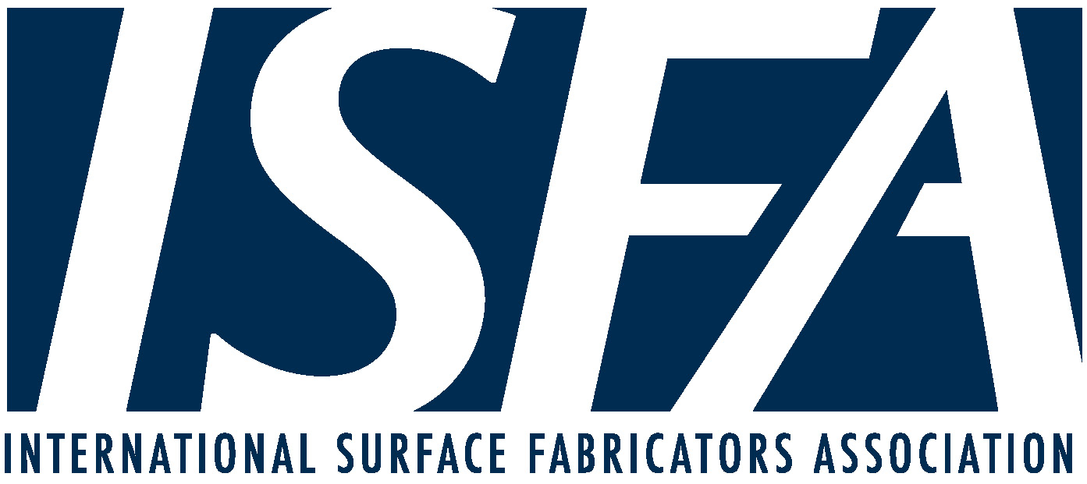

Reopening Safely—A Practical Guide during the Coronavirus Pandemic

With many states and localities easing their shelter in place orders, we recognize that many of you will begin reopening facilities and bringing back employees. It is important that each of you take steps to protect employees and customers from exposure to the coronavirus. Moreover, it is important to take precautions to minimize the risk of customers or employees claiming you are liable if they contract COVID-19.

The Center for Disease Control (“CDC”) and the Occupational Safety and Health Administration (“OSHA”) have issued guidance on preparing workplaces to guard against COVID-19. In addition, some states have issued standards and some have mandated that these standards be applied. Insurers and other groups have also issued suggested precautions employers, manufacturers, and retailers should take. Whether mandated or just considered suggestions, these guidelines should be applied to minimize risks to employees and customers, and the possible liability if a customer or employee becomes ill with the coronavirus.

After reviewing the CDC, OSHA, and other guides, the information below has been compiled as a recommendation regarding steps to be taken to protect employees, subcontractors and customers from the coronavirus.

  - The employer should have each employee verify that they have not had or been exposed to anyone who has had COVID-19 or symptoms of the virus.

  - The employer should pre-screen workers by temperature checks each day when the employee reports to work;

  - If practical, installers should use temperature checks for all customers before they enter a home or work site. At a minimum, the installer should verify that they have not had or been exposed to anyone who has had COVID-19 or symptoms of the virus.

  - The employer should regularly monitor employees for symptoms of the coronavirus.

  - If any employee is feeling ill or showing signs of the coronavirus, they should be sent home and not report to work until they have tested negative for the coronavirus.

  - If an employee tests positive for the coronavirus, advise employees and customers who had contact with the employee, BUT DO NOT USE EMPLOYEE’S NAME.

  - The employer should stager shifts, breaks and lunch to avoid congregation.

  - Manufacturers, fabricators, and installers should limit the number of employees and customers present at any one time in its facilities or work sites.

  - The employer should require employees and customers practice social distancing by mandating they remain at least 6 feet apart.

  - The employer should consider installing clear plastic barriers at reception desks, registers, etc.

  - The employer should provide new mask and gloves to employees every day, and mandate that they wear them. It makes sense to have these items available for customers, too.

  - The employer should require employees wash their hands with soap, and consider posting information on hygiene. If hands cannot be washed, such as on some job sites, the employer should supply and mandate the use of hand sanitizers. (Posters can be found on ISFA’s COVID-19 Resource page.)

  - The employer should clean and disinfect frequently touched objects and surfaces such as workstations, keyboards, telephones, samples, and doorknobs.

  - The employer should not allow employees to use same the same phones or other equipment without disinfecting them first.

  - The employer should disinfect and clean all work spaces at least daily.

  - The employer should implement feasible engineering controls, such as increased ventilation.

While taking all of these precautions may not be practical for every business, fabricator, or contractor, we recommend that you take as many of these precautions as possible, and document your efforts. It is also recommended that you require your subcontractors follow these rules.

Taking these steps will not absolutely eliminate the risk of exposing someone to the coronavirus, but will minimize that risk. As always, you should also check your state and local governments to ensure you are adhering to any additional requirements or guidelines. Taking these precautions will reduce your risk of being found liable if a customer or employee contracts the virus. We recommend you mitigate your risk by showing that you have taken all reasonable steps to avoid spreading COVID-19.

With the rapid pace at which laws, rules and orders are being issued, and now the lifting of shelter in place orders, ISFA is working to keep members informed and updated regarding obligations during the COVID-19 crisis.

Notice: We thank our friends at WFCA for sharing their guidance and collaboration in the creation of this document. The information contained in this update is abridged from legislation, court decisions, and administrative rulings, and should not be construed as legal advice or opinion, and is not a substitute for the advice of counsel.

5-1-20

